AgBeh Series:

Showing proper calibration (peak overlap), Intensity Differences, Resolution differences and reproducibility (Measurement times between 30 seconds and 300 seconds)

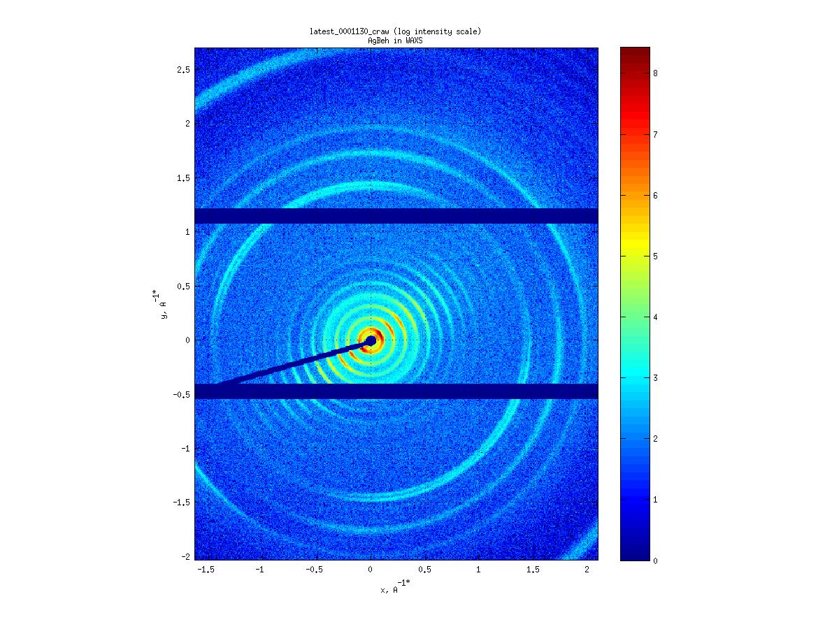 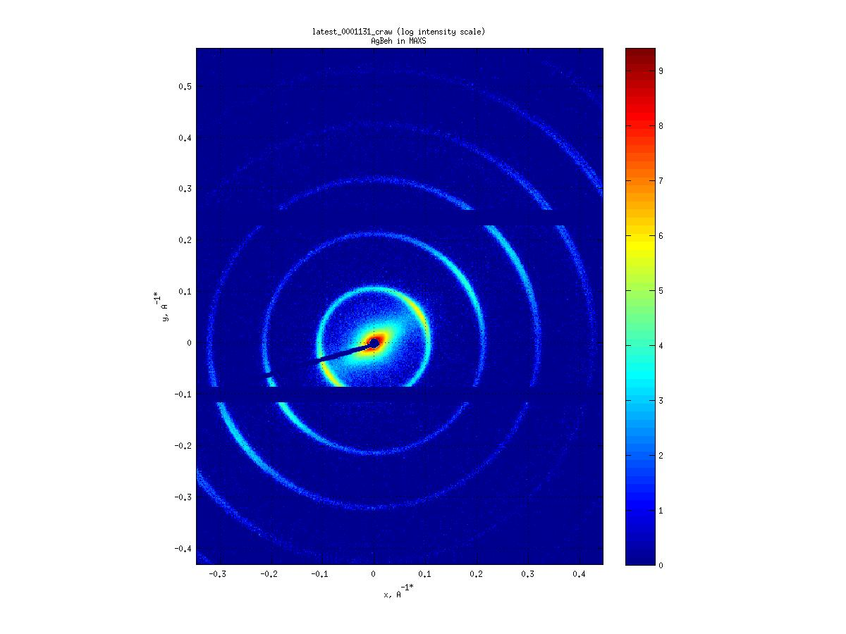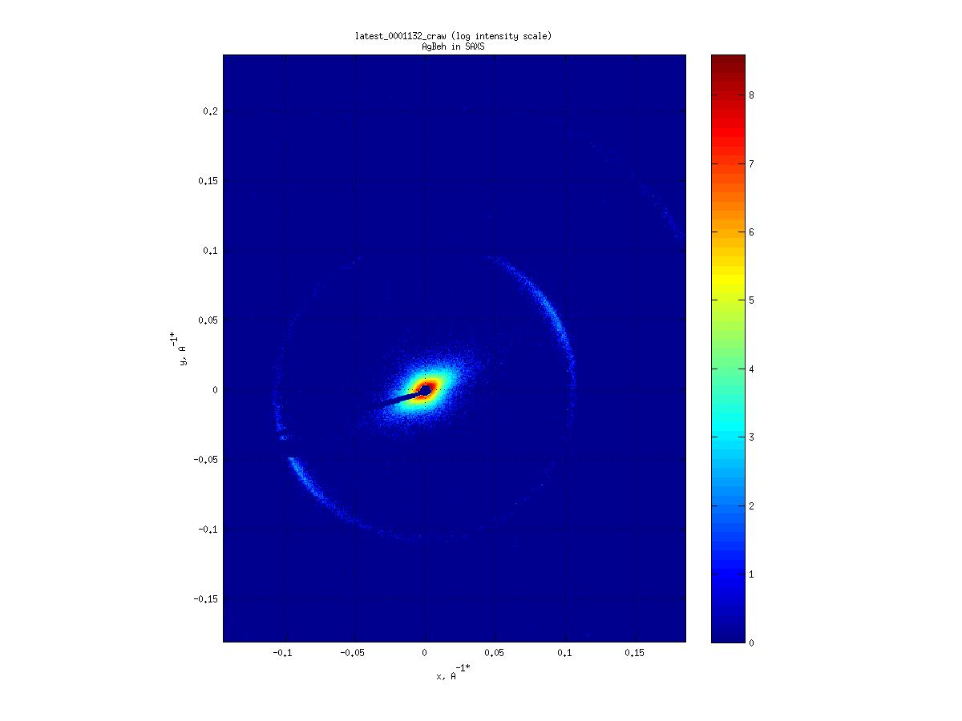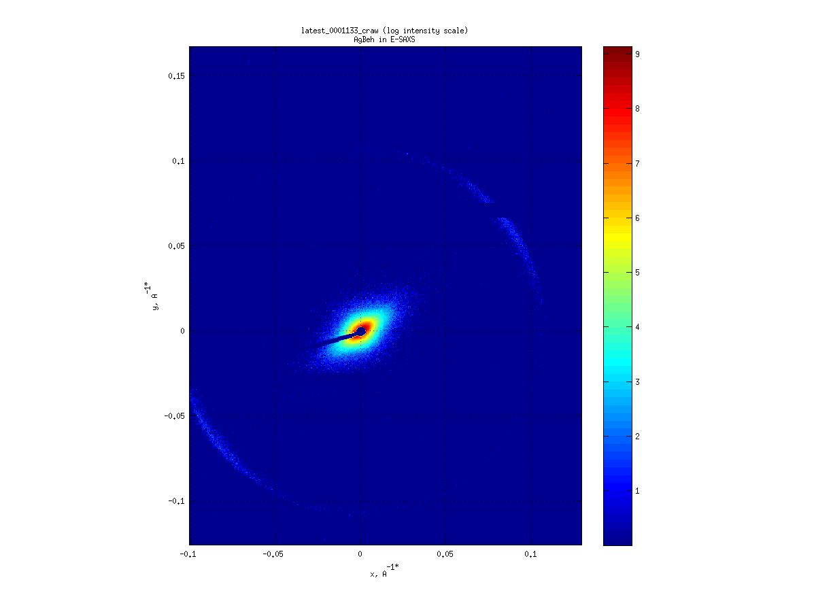

MAX

WAXS

SAXS

ESAXS

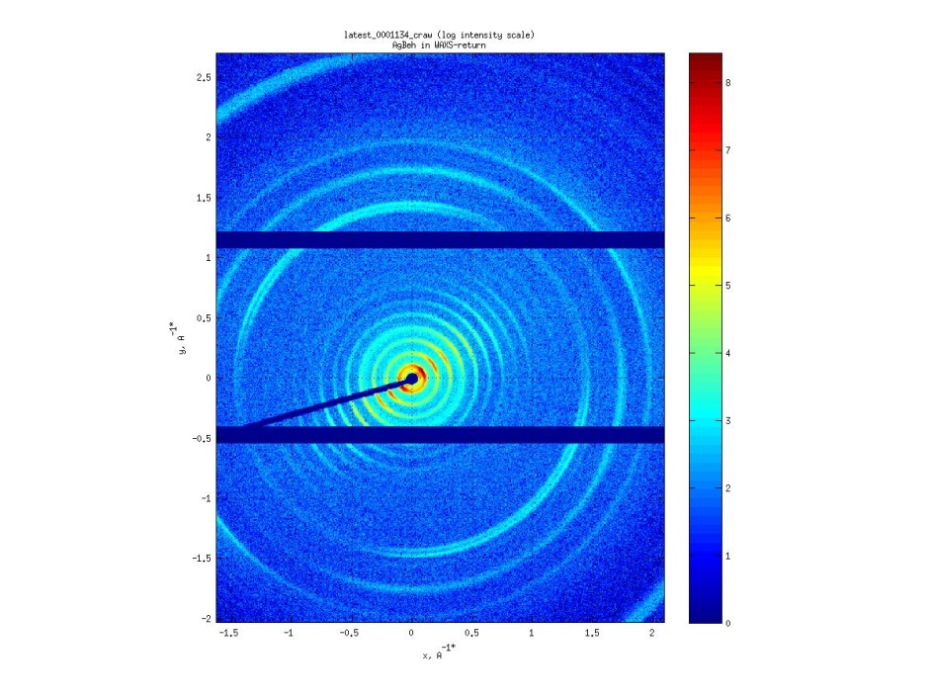

WAXS 2nd time

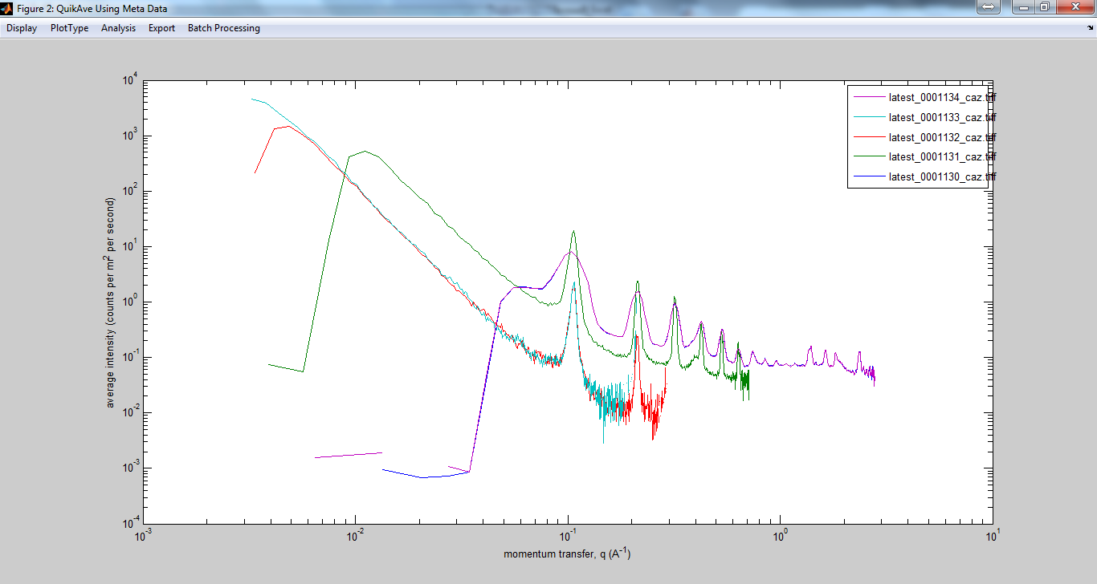

Extreme WAXS (Extreme Offset:

With the normal centered WAXS measurement one obtains measurements up to 2theta=35 degrees.

By displacing the detector in WAXS one can get up to 2theta=60 degrees

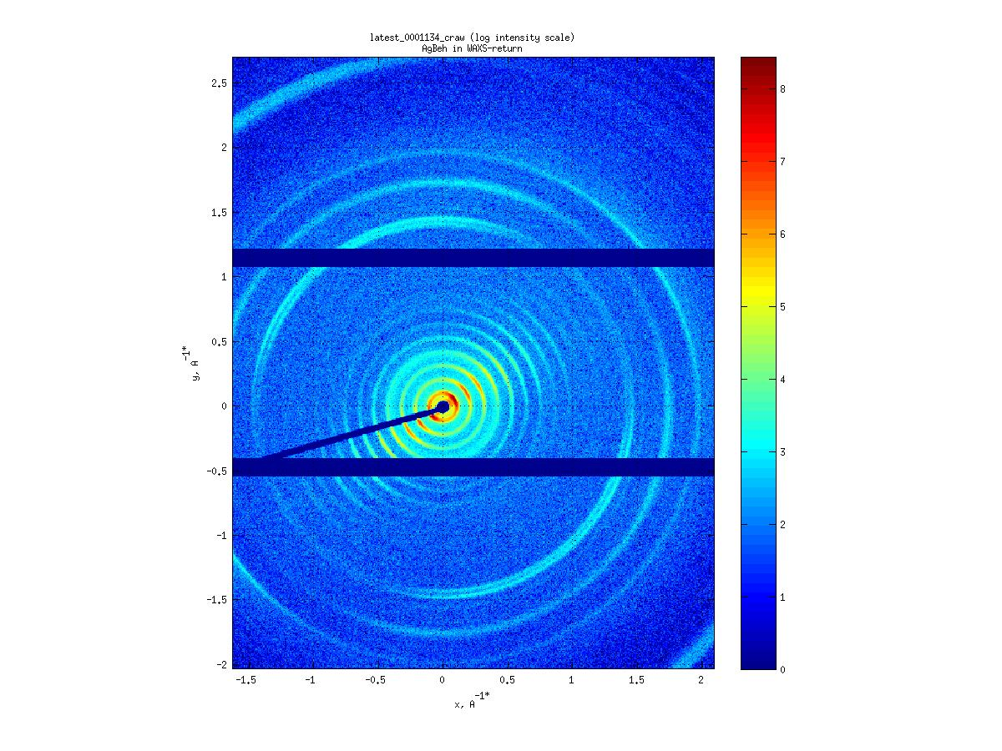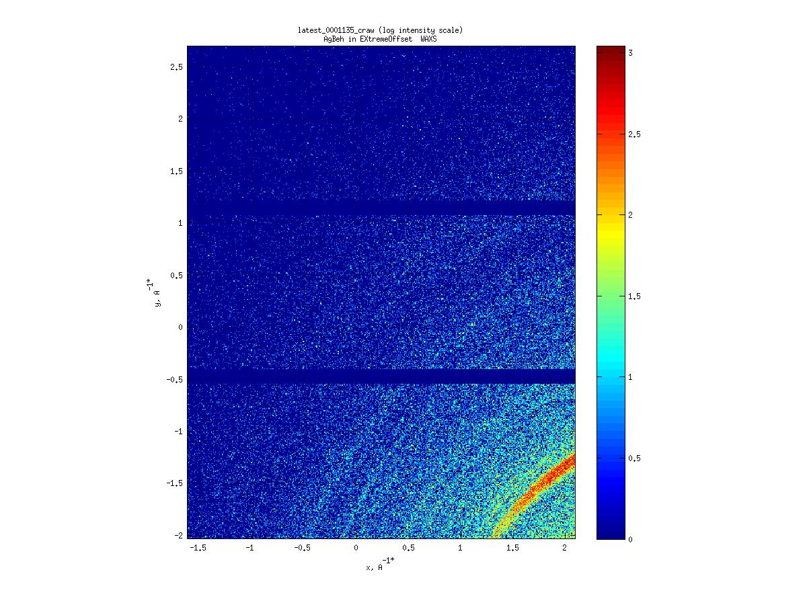

Offset WAXS

WAXS

WAXS image has a maximum 2theta Angle of ~40 degrees

Offset WAXS has a maximum 2theta Angle of ~62 degree

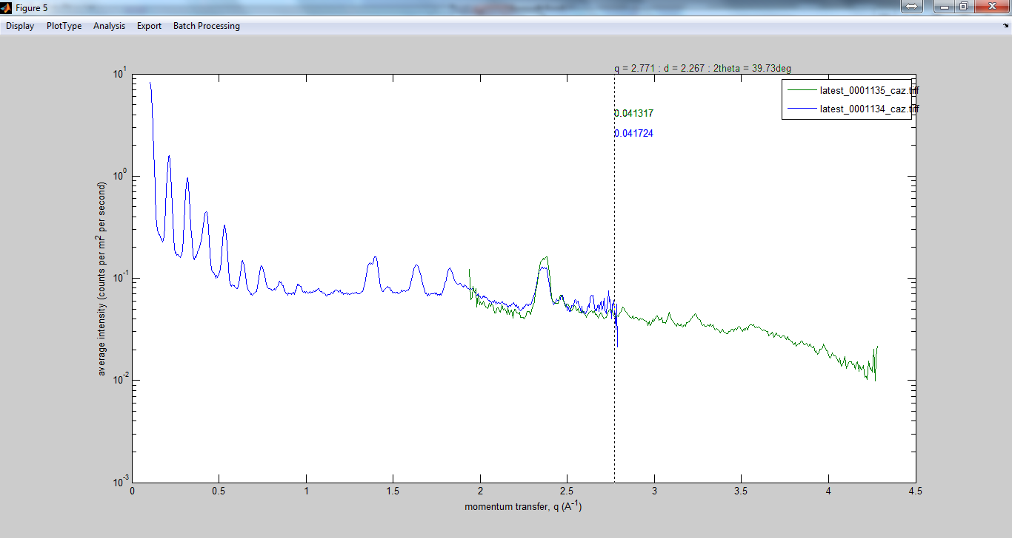

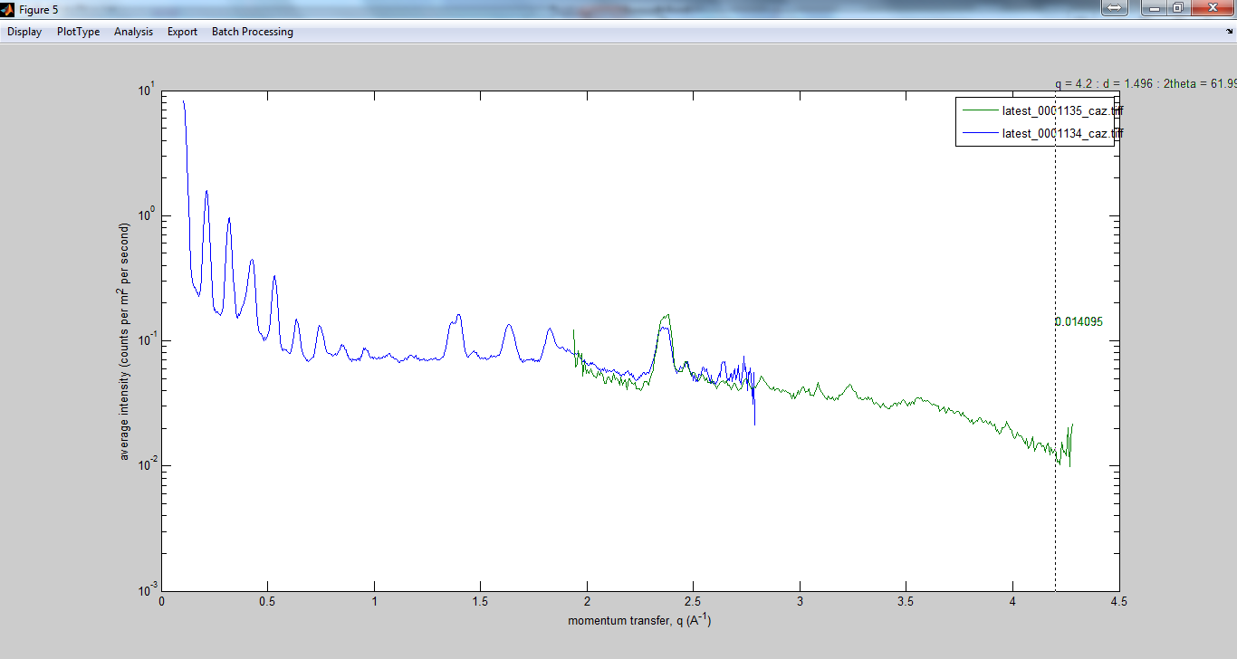

Sample 2: In different configurations (WAXS, MAXS, E-SAXS)

WAXS

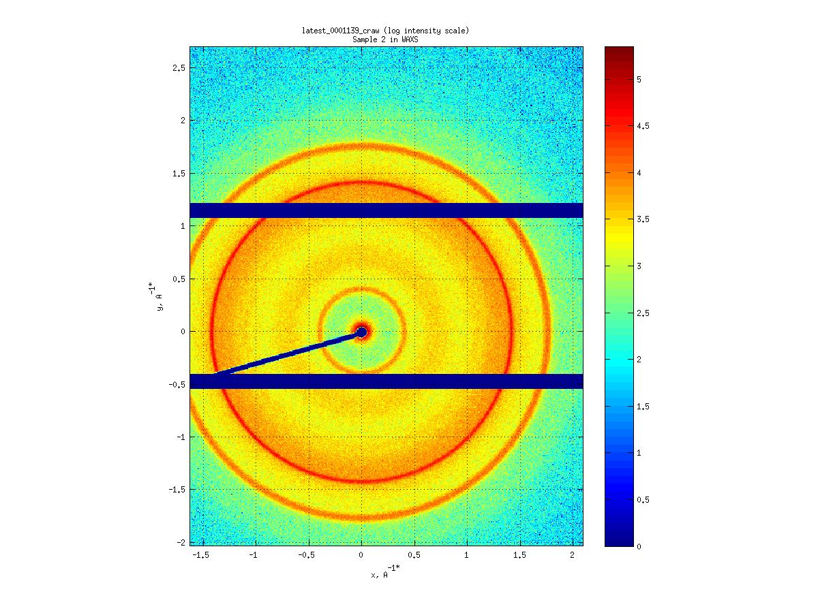

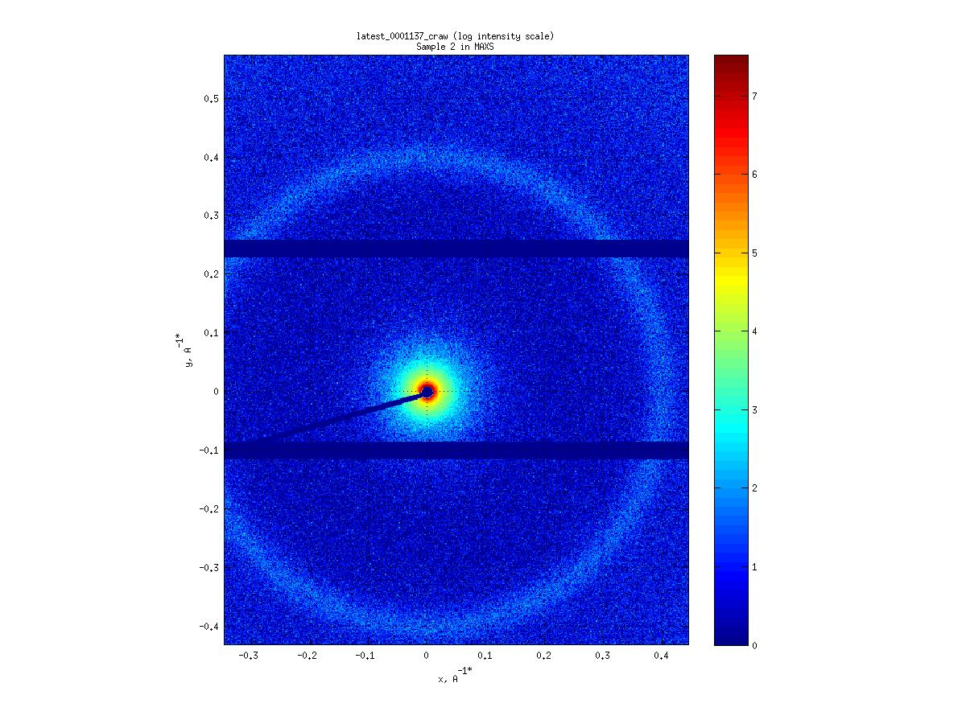

MAXS

’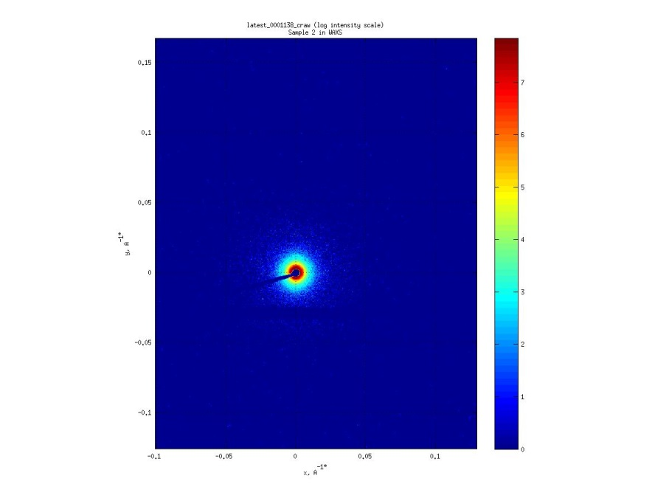

MAXS

Plotted together with no correction for intensity, Beamstop Mask has been applied

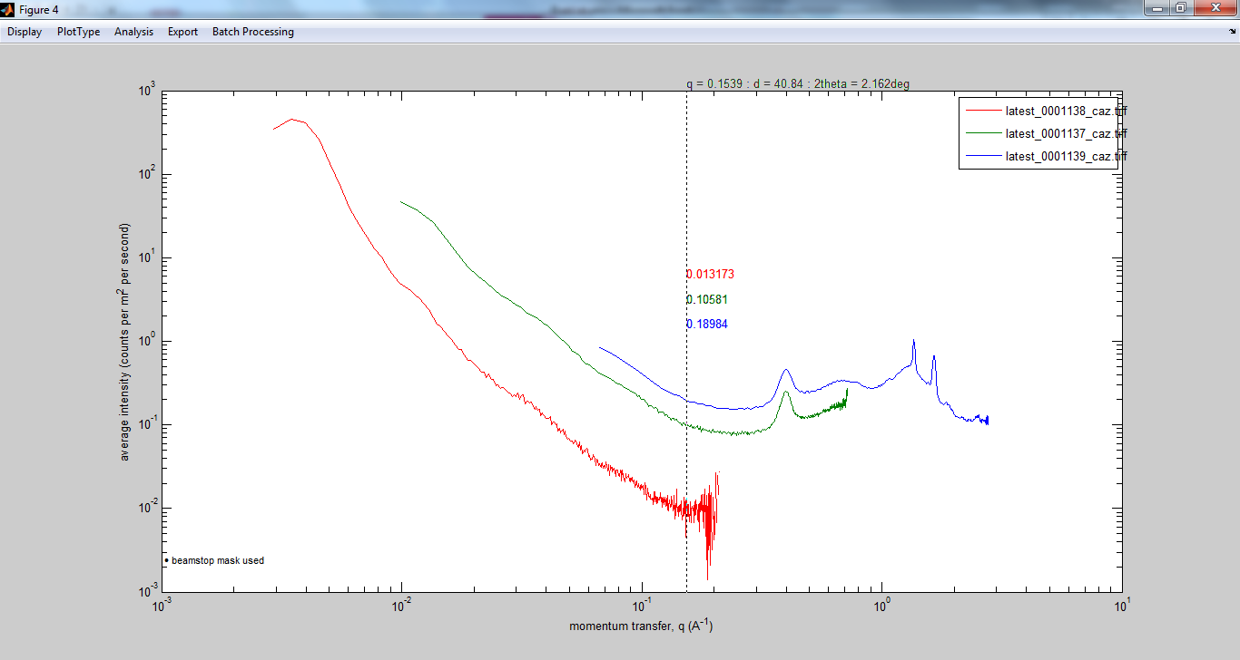

MAXS

Lower Q limit 3E-3 1/Å

High Q limit: 2.8 1/Å

Intensity differencesover a factor of 2 between E-SAXS and WAXS.

Sample 3: In different configurations (WAXS, MAXS, E-SAXS)

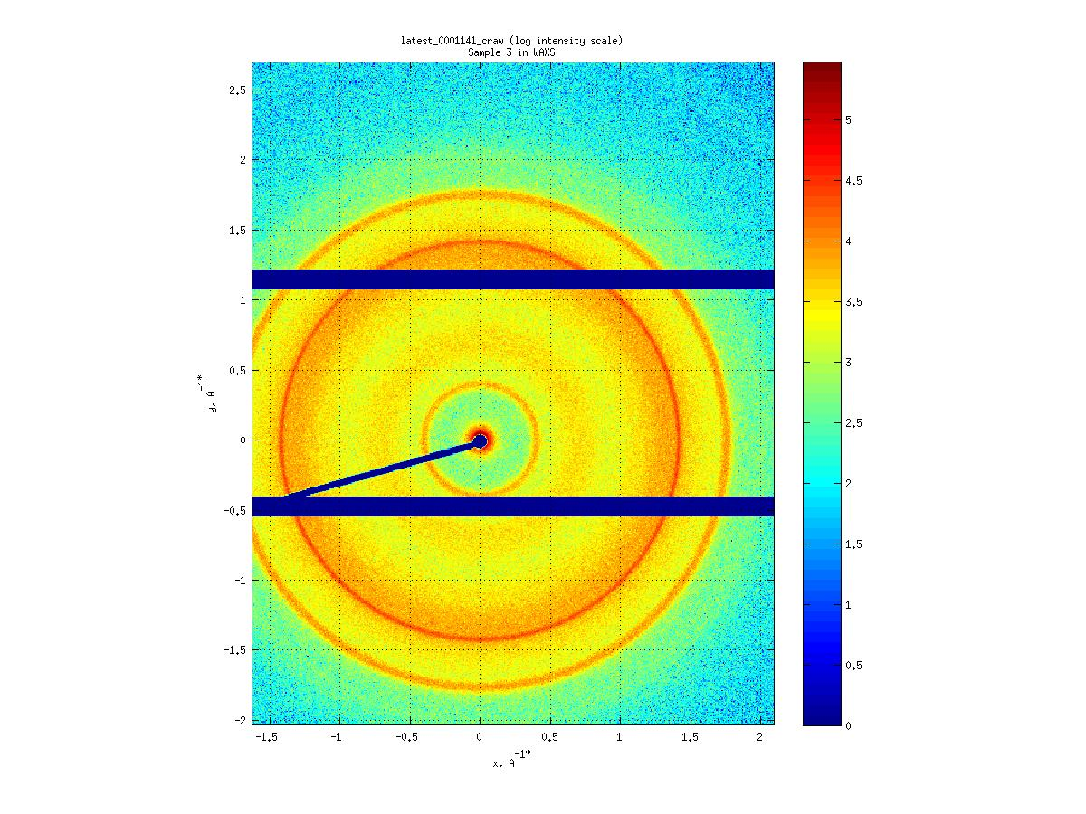

WAXS

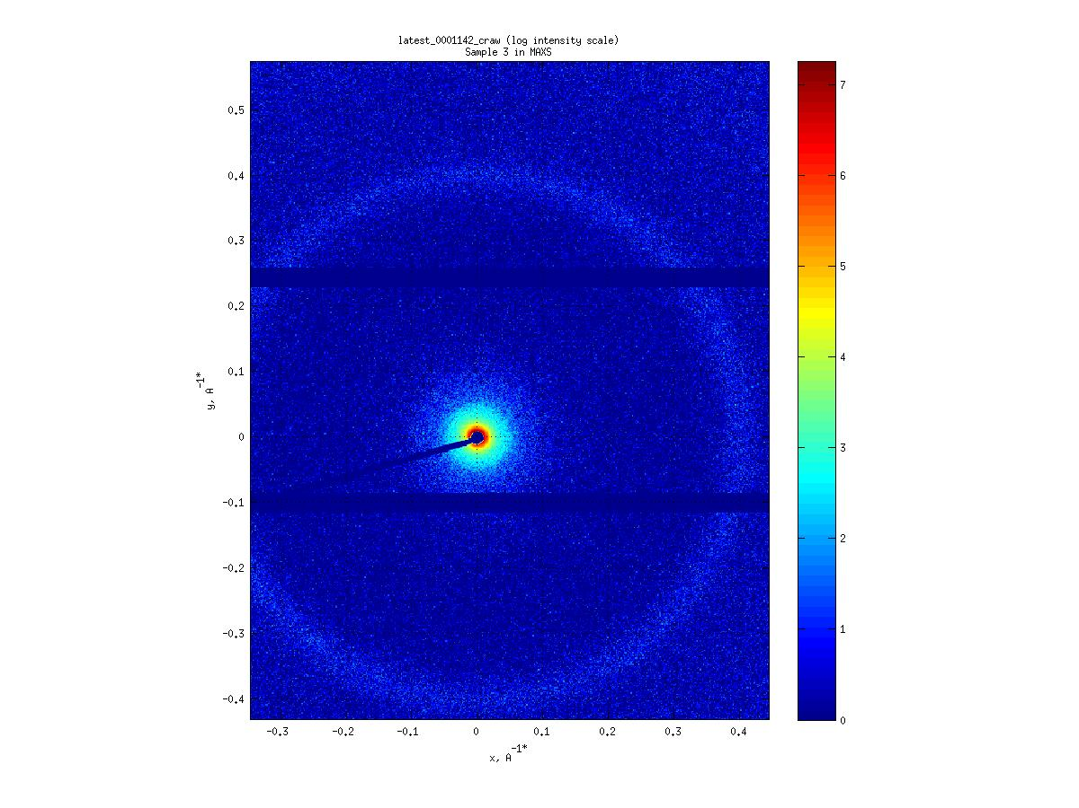

MAXS

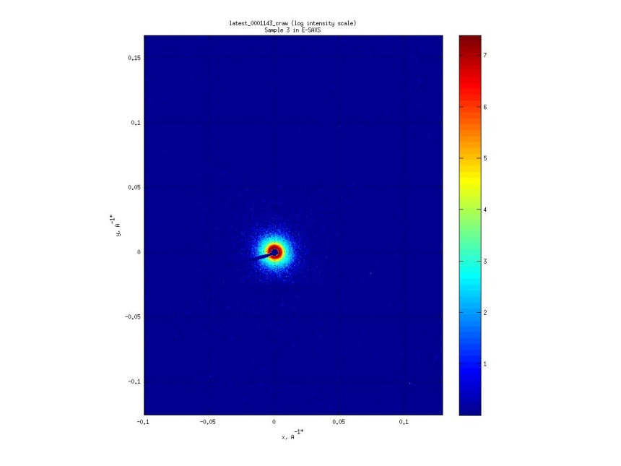

ESAXS

Plotted together with automated correction for intensity and sample transmission (Beamstop Mask applied) Notice the potential peak at 4E-3 1/Å. Size:~156nm

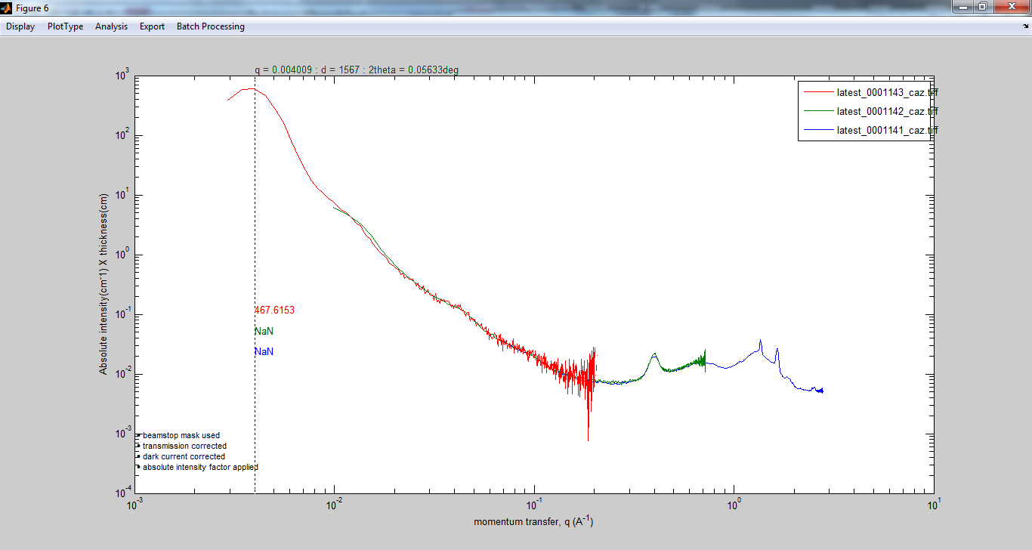

Sample 3:

Is there a real low-q peak (hard to tell…even in E-SAXS)

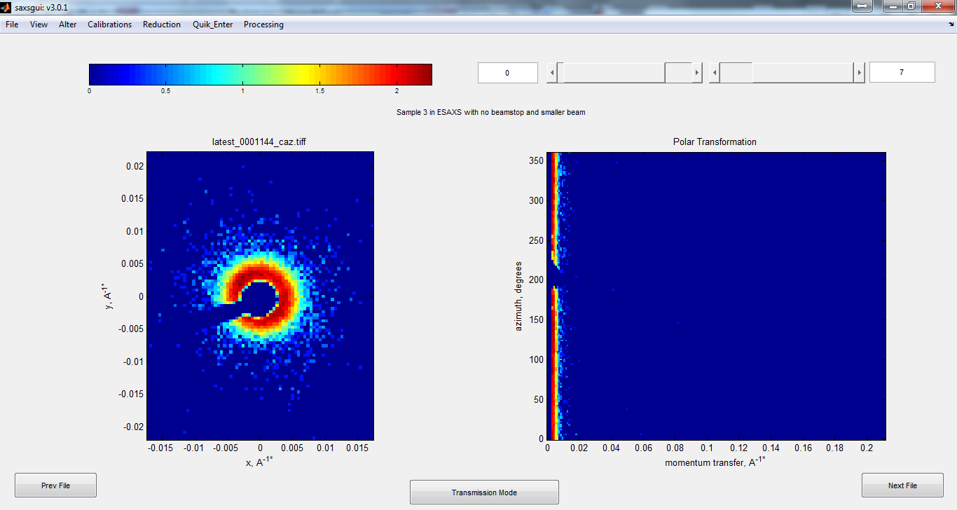

But not in Beamstop Free Mode : There is definitely a ring

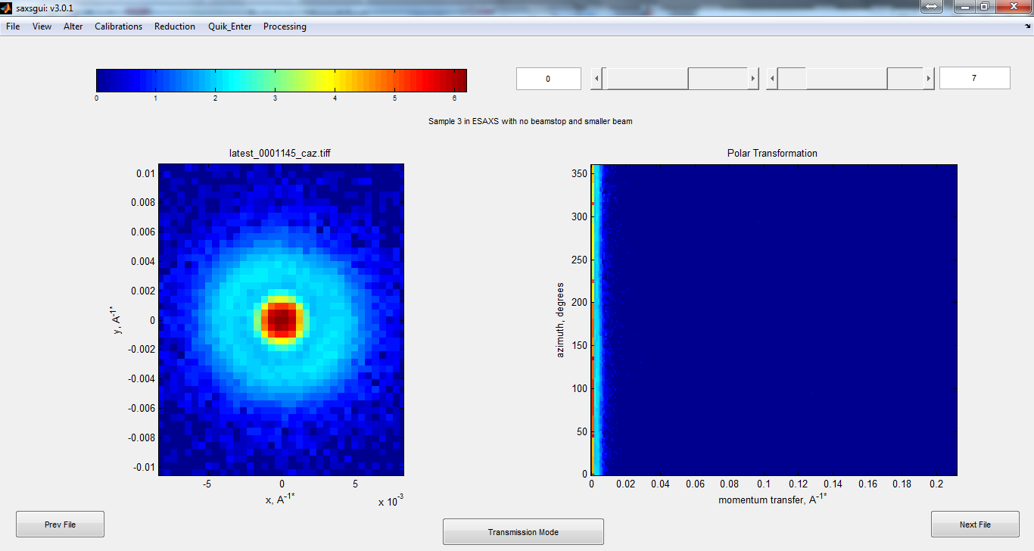

Comparing with Beamstop (Green) and without beamstop (Blue)

Direct Beam consists of Direct Beam and Scattering from 7 micron Aluminized Mylar detector window

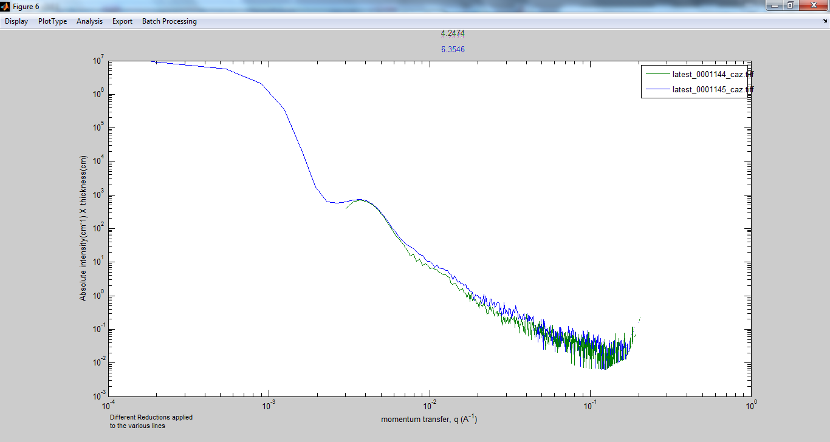

Sample 1: Investigating even higher resolutions

ESAXS: Notice “oblong ring”

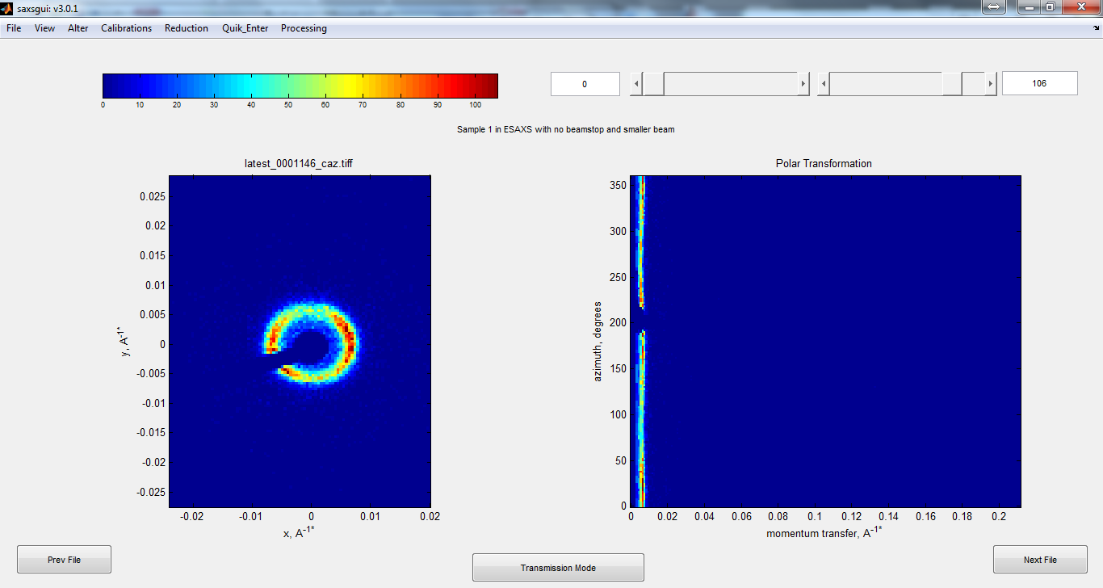

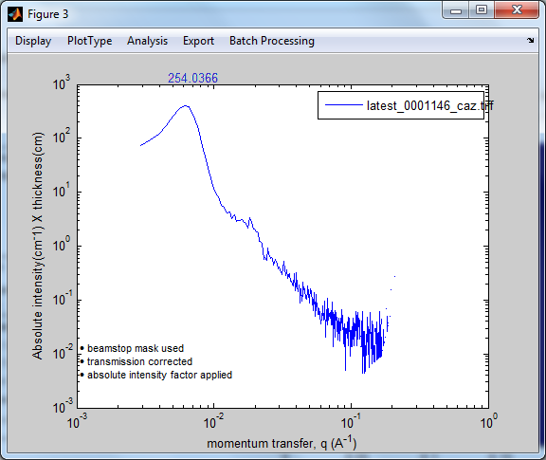

Sample 1: With even smaller apertures

Standard ESAXS

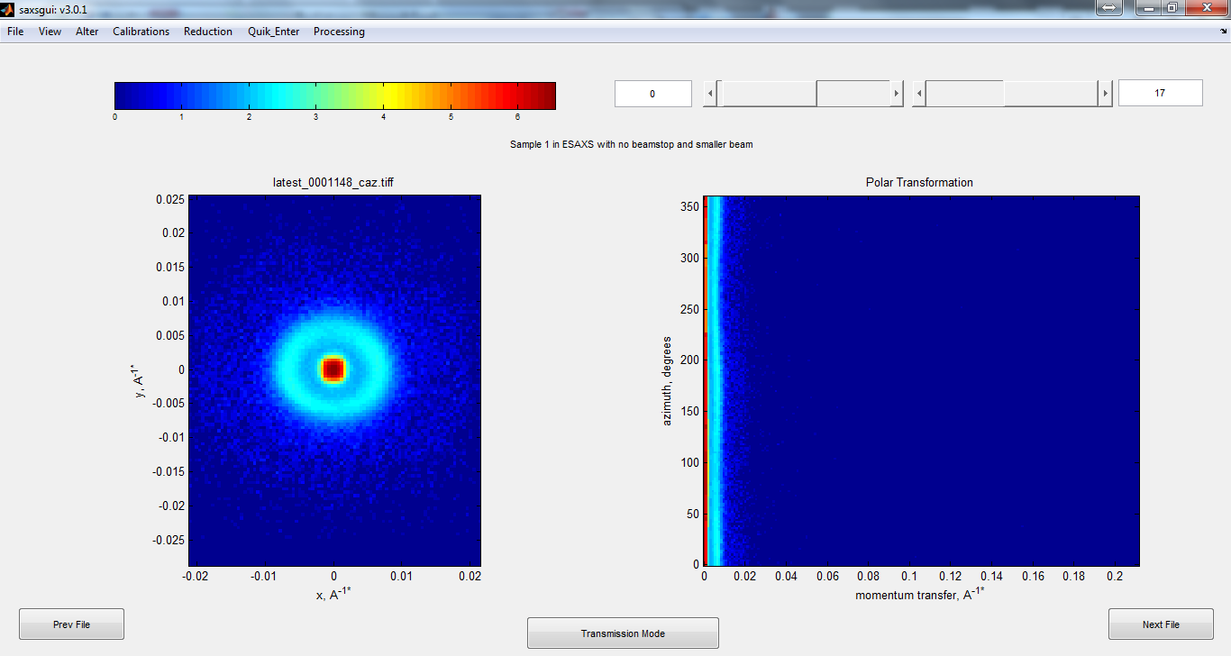

0.2 mm apertures

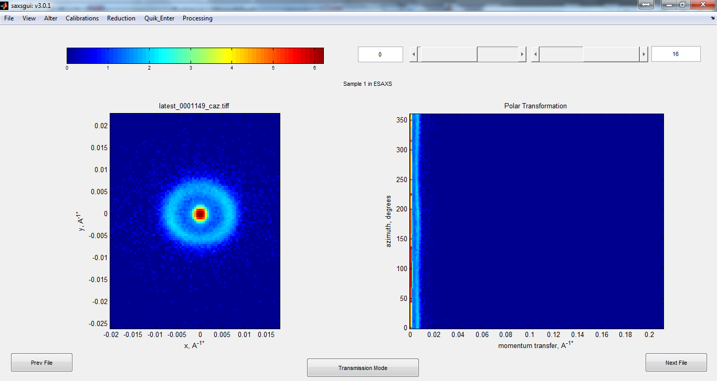

0.1 mm apertures

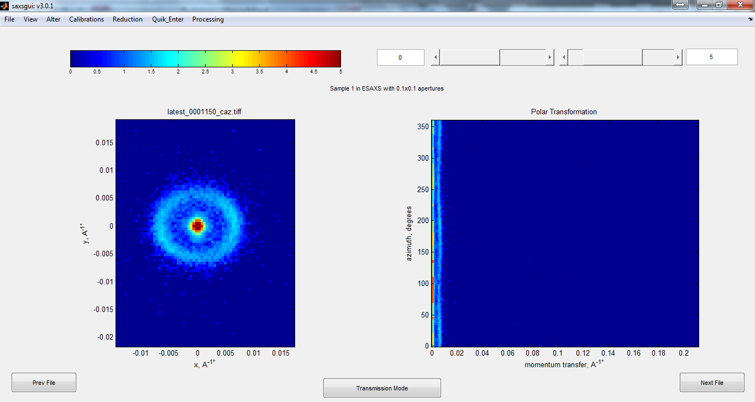

Beam is 2 picsle FWHM (0.3 mm)

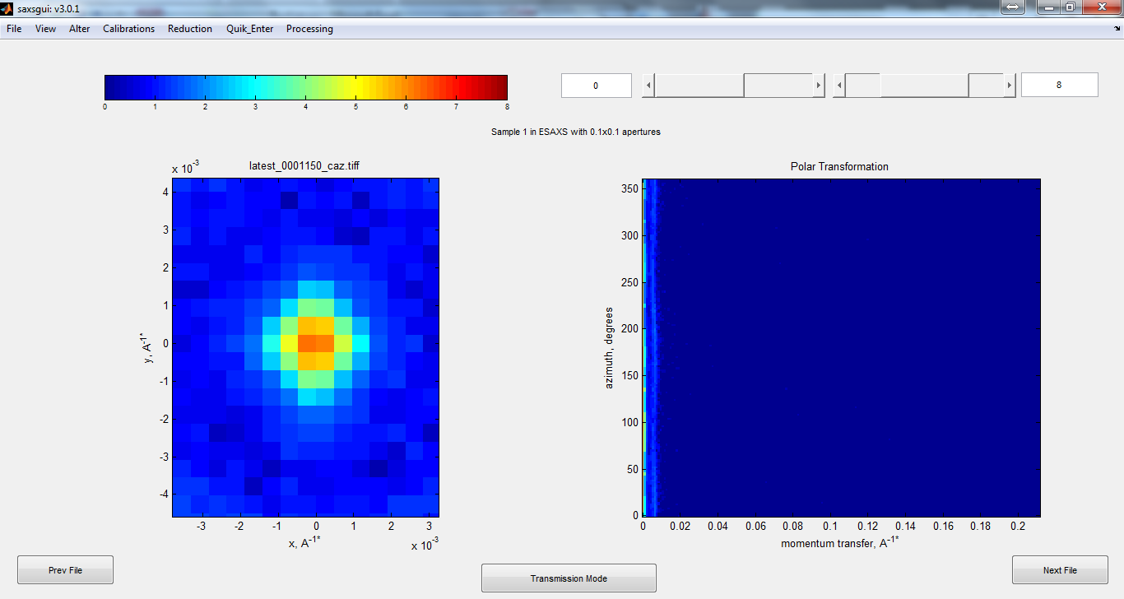

Plot of measurements with direct beam.

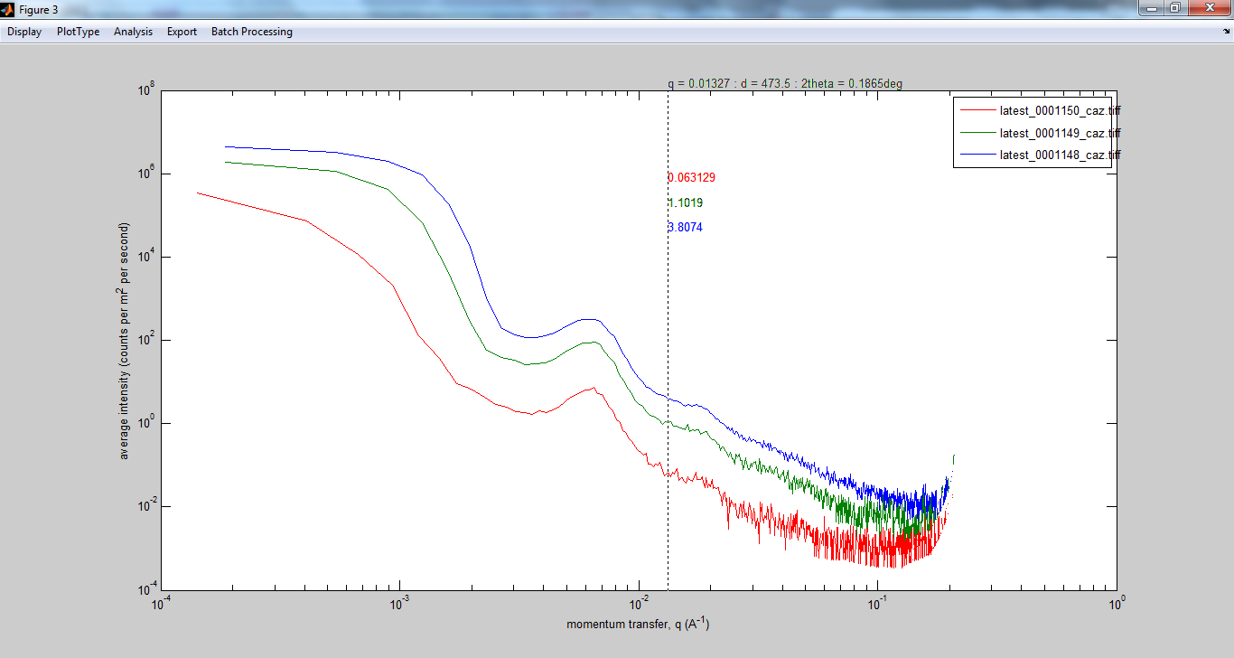

High resolution costs….a factor of 20 intensity difference between blue and red.

Heating copolymer 5

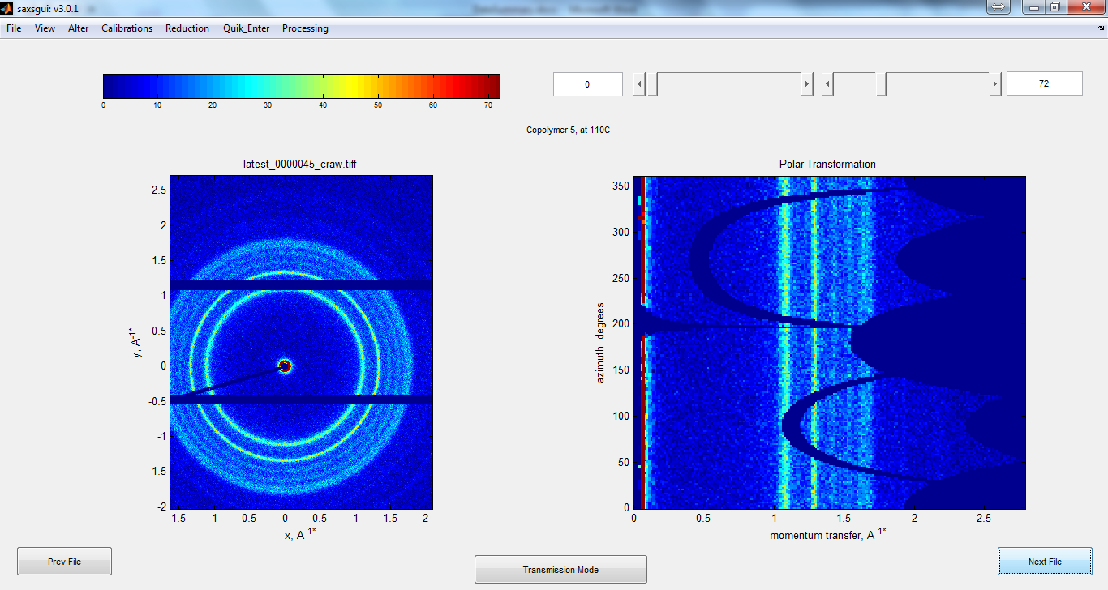

Before Heating

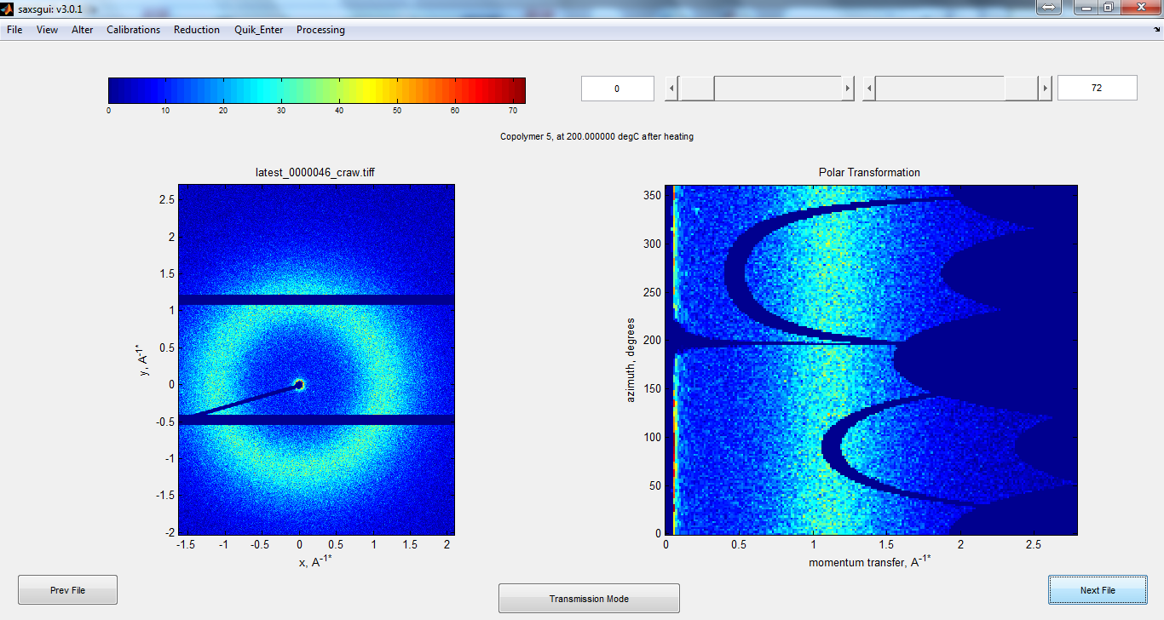

At 200 C

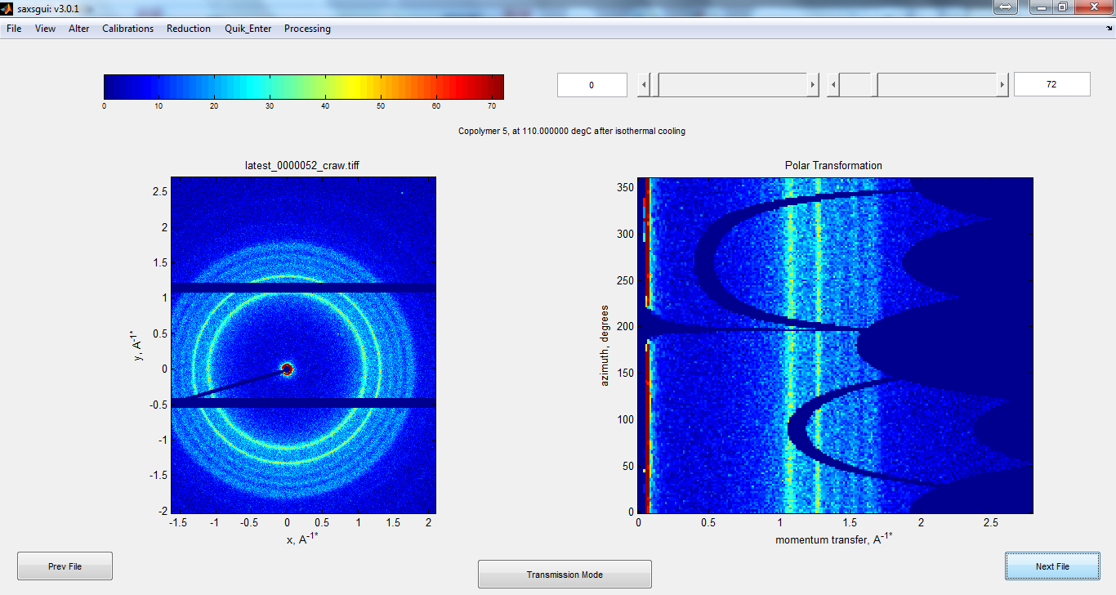

After cooling

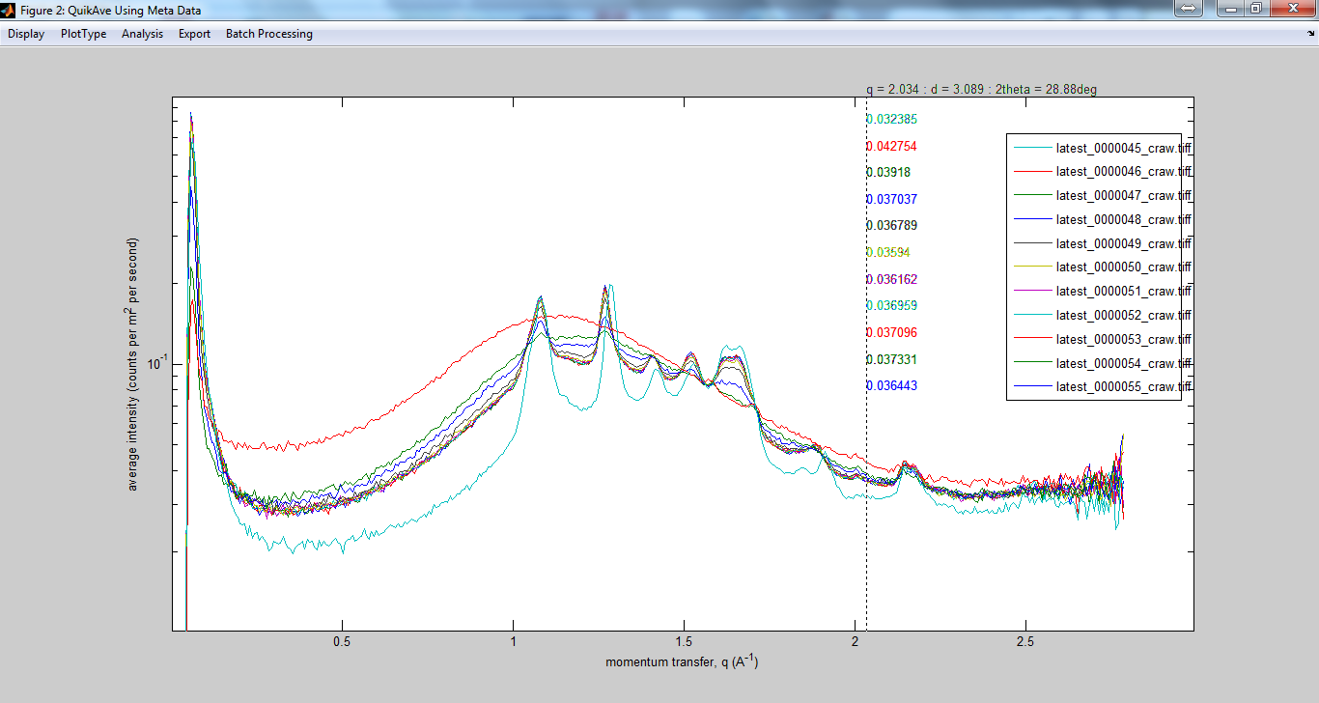

Sample: Copolymer 5 in an aluminum pouch.

Temperature Ramp: Heating to 200C, Cooling to 110C. Recording the re-crystallization every minute.

Light Blue- Before Heating

Red: at 200C

Others: Recrystallization

Note:

There is an unexpected peak-shift in some of the peaks.

GISAXS:

5 min measurement

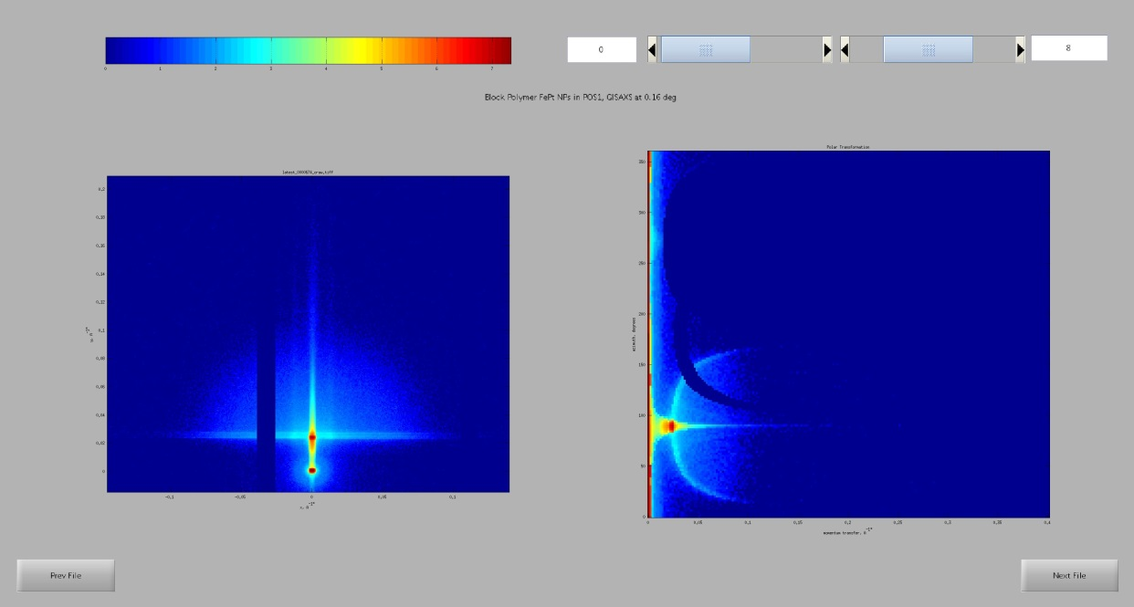

A slice along the Yoneda Line shows a 1st and 2nd order reflection of a structure at 0.0133 corresponding to a structure of 47 nm

